Chapter 6

**LOW LEVEL DESIGN**

**6.1 Introduction**

During the detailed phase, the view of the application developed during the high level design is broken down into modules and programs. Logic design is done for every program and then documented as program specifications. For every program, a unit test plan is created.

The entry criteria for this will be the HLD (High Level Design) document. And the exit criteria will the program specification and unit test plan (LLD).

**6.2 Use case diagram**

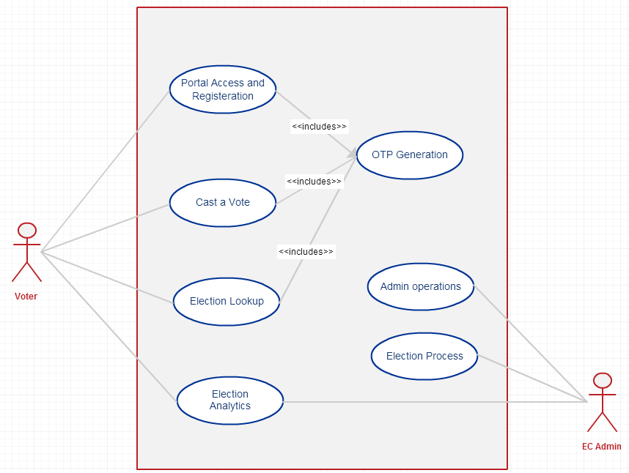

Figure 6.1 Use Case Diagram